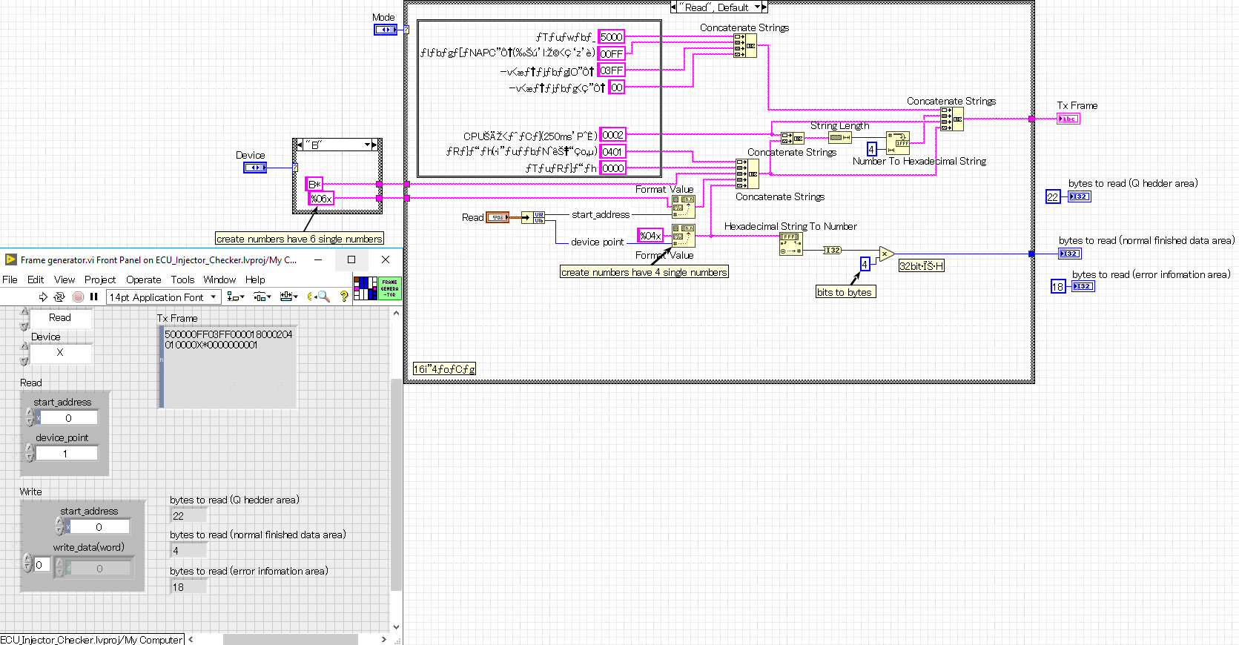

Device has X,Y,M,L,F,V,B,D,W ( for each of structure cases)

%06x, %04x is the defined type of hexadecimal number (convert from decimal)

00FF : 255 , 03FF : 1023

[ subheader : 5000

00FF : network, PC number

03FF : requested unit IO number

00 : request destination unit station number ]

4 : bit to byte

[ 0002 : CPU monitoring timer (250ms units)

1401 : Command

0000 : subcommand ]

Question : 1. what is start_address and device_point ?

